### Genba Sopanrao Moze Trust’s

**GENBA SOPANRAO MOZE COLLEGE OF PHARMACY**

**(B. PHARM)**

**Wagholi Pune-412207**

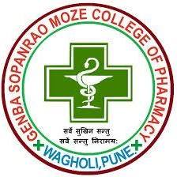

**STUDENTS PRACTICE SCHOOL REPORT**

(AS PER PCI NORMS)

**Dr. Rajesh Oswal Mrs. Ashwini Jadhav**

### Principal Co-Ordinator

“AN OVERVIEW ON INCOMPATIBILITY STUDIES”

***Project submitted to the Savitribai Phule Pune University, Pune***

***In Partial fulfillment for the degree of***

**BACHELOR OF PHARMACY**

**Submitted by**

**Tejaswini Mali**

***Final Year B. Pharm***

**Project Guide**

**Miss. Ankita Bankhele**

***M. Pharm (Pharmaceutics)***



### Genba Sopanrao Moze Trust’s

**GENBA SOPANRAO MOZE COLLEGE OF PHARMACY GAT No. 2181, Wagholi, Tal: Haveli, Dist.: Pune (M.S.)-412 207**

Website- [www.](http://www.pravara.in/)gsmozecop.com

**E-mail: gsmcop@rediffmail.com**

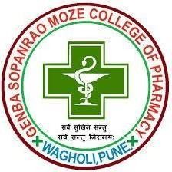

ENDORSEMENT

This is to certify that the project work presented in the entitled,

**AN OVERVIEW ON INCOMPATIBILITY STUDIES**

**by**

**Miss. Tejaswini Govindrao Mali**

*which is being submitted here with in the partial fulfillment of* ***degree of Bachelor of Pharmacy*** *is a result of work completed has been carried out personally by*

***Miss. Tejaswini Govindrao Mali*** *under the guidance of* ***Prof. Ashwini V.Jadhav*** *(Department of Pharmaceutics) Assistant Professor at GSMT’s Genba Sopanrao Moze College of Pharmacy, Wagholi, Pune.*

*Date: / /2022* **Dr. Rajesh Oswal**

**Principal**

Place: Wagholi, Pune GSMT’s Genba Sopanrao Moze

College of Pharmacy,Wagholi,Pune



CERTIFICATE

This is to certify that the project work presented in the entitled,

“AN OVERVIEW ON INCOMPATIBILITY STUDIES”

**by**

**Tejaswini Govindrao Mali**

*which is being submitted here with in the partial fulfillment of degree of* ***Bachelor of Pharmacy*** *is a result of work completed at GSMT’s Genba Sopanrao Moze College of Pharmacy, Wagholi, Pune, which has been carried out under my guidance and supervision during academic year 2022-23.*

*I have great pleasure in forwarding it for evaluation.*

#### 

#### Date: / /2022 Guide:

**Miss. Ankita Bankhele**

Place: Wagholi, Pune Assistant Professor

Dept. of Pharmaceutics

GSMT’s Genba Sopanrao Moze College of Pharmacy,

Wagholi, Pune

#### 